EXPERIMENT -13
Hypothetical using T-Test
Aim:
To test whether the average IQ score of a sample of students differs significantly from a population mean IQ score of 100
Procedure:
- Null hypothesis
- Alternative hypothesis
- Sample
- Z-Test
- Decision Rule

Program:
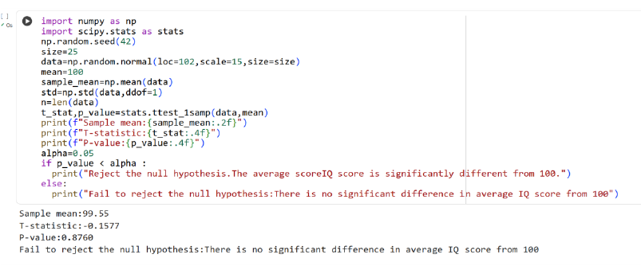

Result:
Thus the python program for hypothetical test using T-Test is executed and output is verified successfully

